Apply definitions of decibels and decades
- (vin/vout to dB) If an electronic component takes a 1.0v sine wave as input and output a 0.1v sine wave, how much attenuation would it have?

- (vin/dB to vout) If you input a 2.4 V sin wave into a circuit that attenuated it by -32dB, what would the amplitude of the output waveform be?

- (out/dB to vin) A circuit attenuates an input signal by -68 dB to produce a 0.5 V signal. What is the amplitude of the input signal?

- (fhi/flo to decades) How many decades separate 10kHz and 30kHz?

- (fhi/decades to flo) What frequency is 1.5 decades below 300kHz?

- (flo/decades to fhi) What frequency is 1.5 decades above 10kHz?

Interpret a real Bode plot
The following Bode plot is from a Chebyshev low pass filter with corner frequency of 10kHz. Use the information in the Bode plot to answer the following questions in the boxes provided.
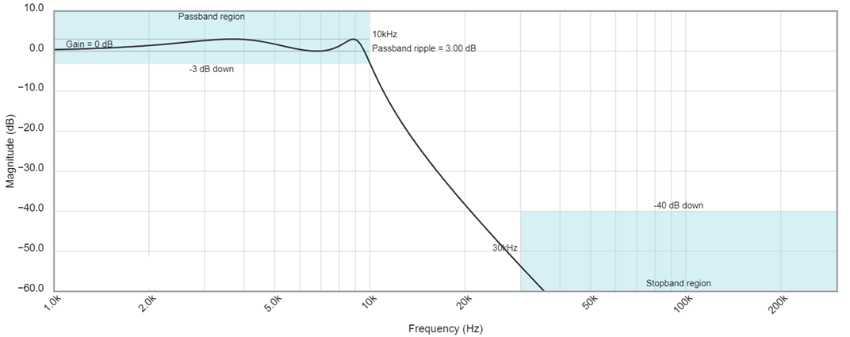
- If you apply a 20kHz sin wave to this filter, how much attenuation will the output experience?

- You want -45dB of attenuation, what frequency sin wave should you apply?

- Estimate the slope of the magnitude in the stop band and use this to estimate the order of the filter. Hint, use the corner frequency as one of your points.

The following Bode plot is from a Butterworth low pass filter with corner frequency of 10kHz. Use the information in the Bode plot to answer the following questions in the boxes provided.
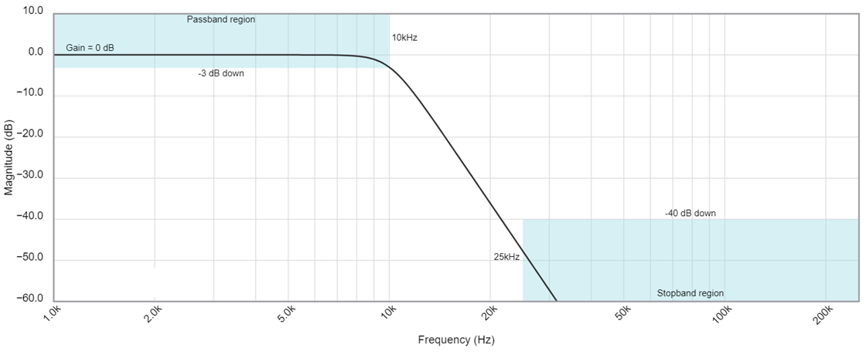
- If you apply a 25kHz sin wave to this filter, how much attenuation will the output experience?

- You want -35dB of attenuation, what frequency sin wave should you apply?

- Estimate the slope of the magnitude in the stop band and use this to estimate the order of the filter. Hint, use the corner frequency as one of your points.

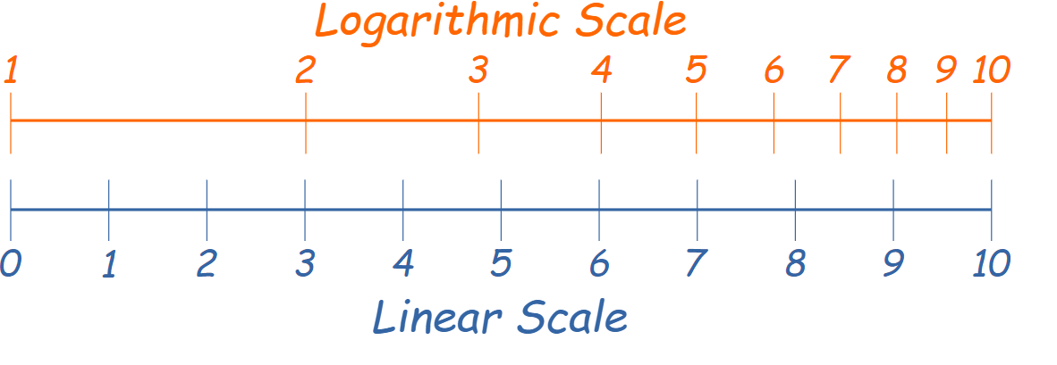
The following Bode plot is from a Bessel low pass filter with corner frequency of 10kHz. Use the information in the Bode plot to answer the following questions in the boxes provided.
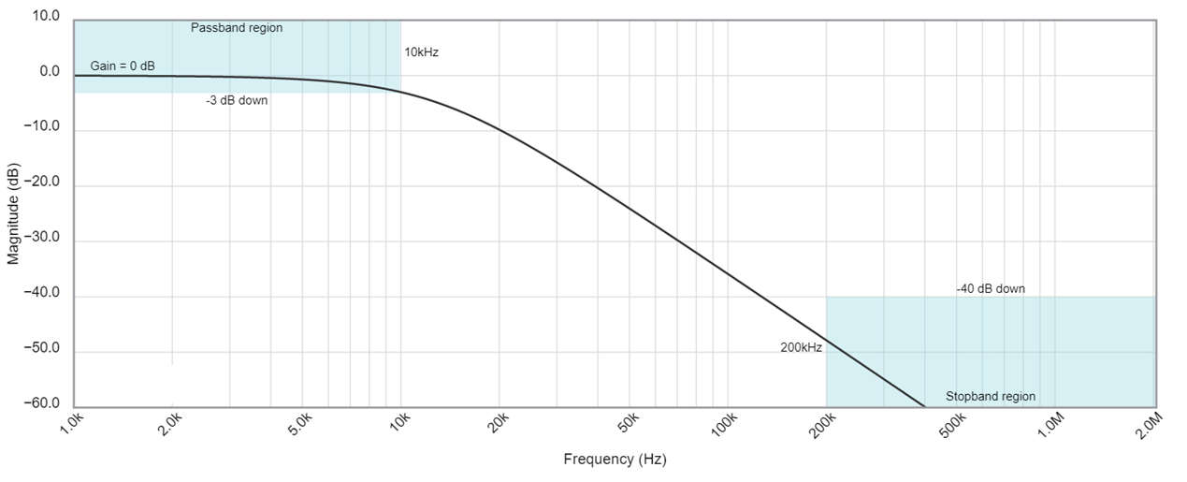

- If you apply a 20kHz sin wave to this filter, how much attenuation will the output experience?

- You want -55dB of attenuation, what frequency sin wave should you apply?

- Estimate the slope of the magnitude in the stop band and use this to estimate the order of the filter. Hint, use the corner frequency as one of your points.

Interpret an ideal Bode plot
- Determine the output attenuation (in dB) from a 80kHz input signal from a 1st order LPF with a corner frequency of 2kHz that has 0dB of attenuation in the passband.
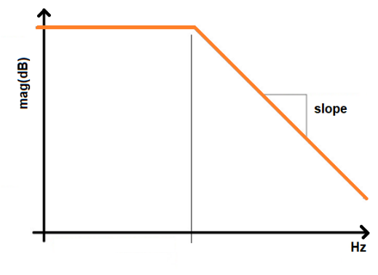

- Determine the input frequency needed to attenuate an input signal by -48dB from a 1st order LPF with a corner frequency of 2kHz that has 0dB of attenuation in the passband.


- Determine the corner frequency of a 4th order LPF that has 0dB of attenuation in the passband and attenuates a 130kHz input by -68dB.


- Determine the order of a filter that has 0dB of attenuation in the passband, a 15kHz corner frequency and attenuates a 90kHz input by -77.8dB.


- Determine the magnitude in the passband of a second order LPF, an 8kHz corner frequency and attenuates a 56kHz input by -13.8dB.


Create a Bode plot from pole/zero map
Use the pole/zero plots for the following problems to draw the Bode plots. You should:
- Annotate the slope values (dB/decade) and draw them correctly on the Bode plot.
- Use the correct corner frequencies.
- In the absence of compelling evidence, assume a 0dB passband.
- If not shown, the complex conjugate poles/zeros do not matter.
You are welcome to check your answers using Matlab – this is much easier than you might. Here is some starter code. Note that Matlab will add lots of details that you are not expected to show in your rough plots.
s = tf('s'); % define the complex variable s
p1 = 100j - 1; % define the coordinates of a pole
z1 = 100j + 1; % define the coordinates of a zero
G = (s-z1)/(s-p1); % define the transfer function that has this constellation
pzmap(G); % Show the pole zero map
waitforbuttonpress(); % waits for a mouse click on the plot to move on
bodeplot(G); % plot it!

- Use the pole zero locations of a transfer function given in the plot below to determine the frequency response of the transfer function. There are two zeros at the origin. The semicircle has a radius of 10.

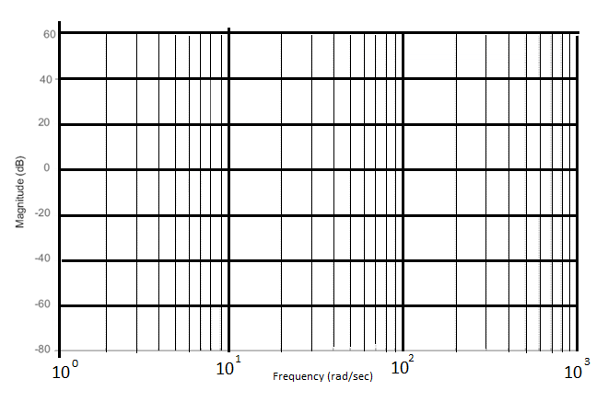
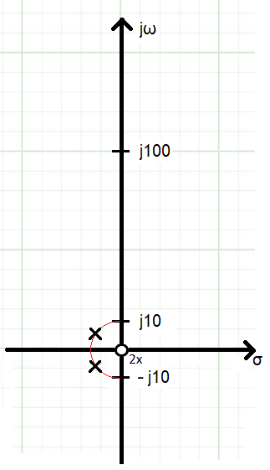

- Use the pole zero locations of a transfer function given in the plot below to determine the frequency response of the transfer function. The semicircle has a radius of 10.


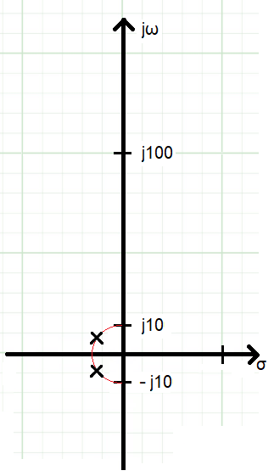

- Use the pole zero locations of a transfer function given in the plot below to determine the frequency response of the transfer function. The real and imaginary axis are scaled differently.


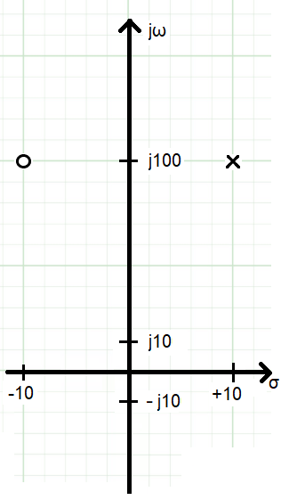

- Use the pole zero locations of a transfer function given in the plot below to determine the frequency response of the transfer function. There is one zero at the origin. The semicircle has a radius of 10.


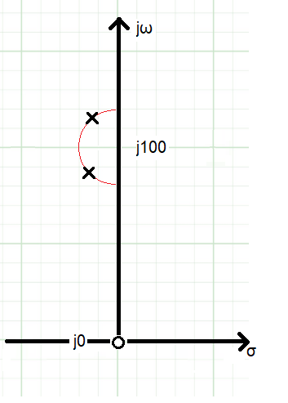

- Use the pole zero locations of a transfer function given in the plot below to determine the frequency response of the transfer function. There is one zero at j100. The semicircle has a radius of 10.


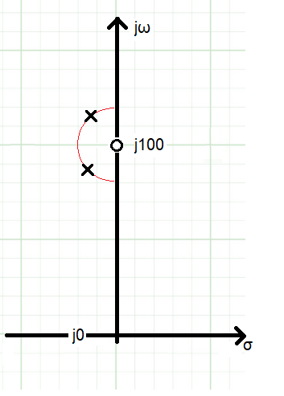

- Use the pole zero locations of a transfer function given in the plot below to determine the frequency response of the transfer function. The real and imaginary axis are scaled differently.

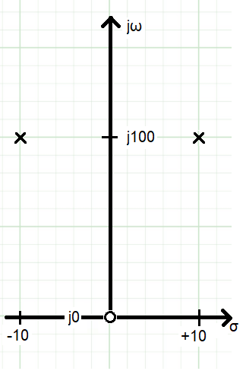

Gain product bandwidth of an op amp
- You are working with an opamp that has a 1MHz gain-bandwidth product. Your circuit is configured to have a gain of 30dB.

  - What is the bandwidth of your circuit?

  - What is the gain (in dB) of a sinusoidal input with a frequency of 10kHz?

  - What is the gain (in dB) of a sinusoidal input with a frequency of 100kHz?

  - At what frequency will the gain drop to 25dB?

Deriving Transfer Functions
Determine the transfer function for the following circuits. Write your transfer function as the product of constants, integrators and canonical first and second order transfer functions (shown in Table 1). In the Type column indicate if the transfer function describes a low pass filter, high pass filter, band pass filter, or notch filter. You are welcome to use to simulator to verify.
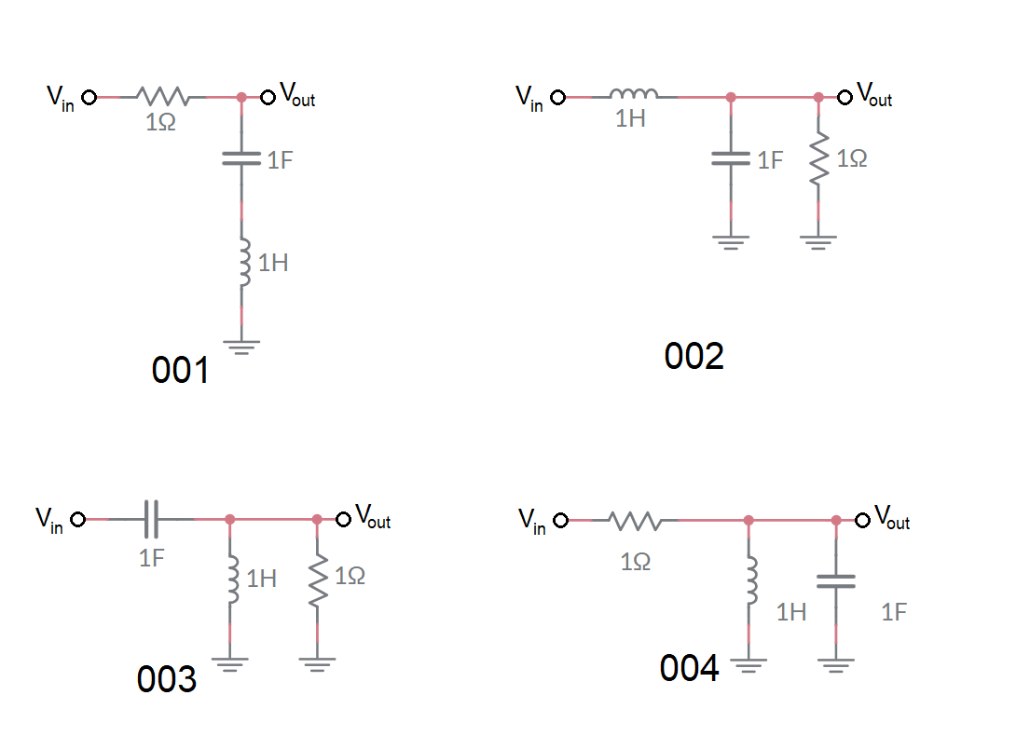

 | Transfer function | Type
001
002
003
004
Practical Application – Buck Converter Filter
A buck converter consists of two subcircuits, a square wave generator and a filter shown in Figure 4. The square wave generator is built from the MOSFET Q3 (represented as a switch). The opening and closing of this switch generated voltage pulses on Vin. The filter consists of the inductor, capacitor and resistor.
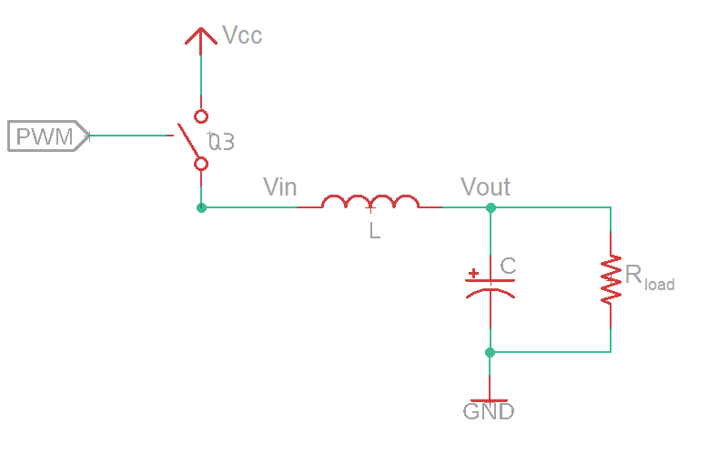
Figure 4: The essential components of a buck converter.

Derive the transfer function Vout(s)/Vin(s) for the filter. Hint, you may want to use voltage divider. Put your answer in canonical form.

What type and order filter is this?

Substitute L=1mH, R = 100Ω, and C = 100uF into your transfer function. Use the definitions of canonical form below to determine the corner frequency of the filter.
Table 1: Canonical form for first and second order systems.
 | First Order | Second Order
Form | $$k\frac{α}{s+α}$$ | $$k\frac{ω_{n}^{2}}{s^{2}+2ζω_{n}+ω_{n}^{2}}$$
Corner Freq | $α$ rad/sec | $ω_{n}$ rad/sec

What is the corner frequency of this filter?

